Project Initialization and Planning Phase
Date | 28 SEPTEMBER 2026
Team ID | SWTID-2026-8907
Project Name | AI-BLOGNEST_API
Maximum Marks | 3 Marks

Define Problem Statements (Customer Problem Statement Template):
Create a problem statement to understand your customer's point of view. The Customer Problem Statement template helps you focus on what matters to create experiences people will love. A well-articulated customer problem statement allows you and your team to find the ideal solution for your customers' challenges. Throughout the process, you’ll also be able to empathize with your customers, which helps you better understand how they perceive your product or service.
Example:
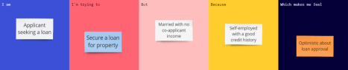
Problem  Statement (PS) | I am  (Customer) | I’m trying  to | But | Because | Which makes  me feel
PS-1 | A user who wants to create blog content | Create a blog quickly and easily. | Writing complete blog content takes a lot of time. | Creating and organizing content manually is time-consuming. | Tired and frustrated.

